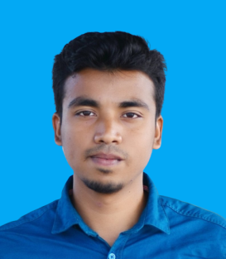**Md Shahin Hossain**

**+8801819014746**

**Cseshahin361@gmail.com**

**Website://** **https://shahin360.github.io/portfolio**

**Linkedin://** **shorturl.at/bTZ37**

Career Objectives

Willing to build up career in a challenging position and to prove myself as a quick learner and highly energetic person to face any challenge in the Information Computer Science and Technology sector where the contribution will be acknowledged, if would be given an opportunity.

Working skills

* MTCNA **(Course complete on daffodil online ltd nation wide ISP Company)**
* PPPoE Server Configuration
* Bandwidth Manage
* Bridge, NTP, VLAN Configuration
* DHCP Server Configuration
* IP Routing Protocols etc
* CCNA
* Subnetting, VLSM, NAT
* TCP/IT, OSI Model
* DHCP Server Configuration
* Static and Dynamic Routing, OSPF, BGP, EIGRP, RIB
* Cisco switch, Ether channel, VLAN, VPN, OS backup and Restore
* LINUX Centos
* Linux Basics, Server Installation on VM, Command (CLI), File Editing with VI
* Web, File, FTP, NTP, DNS, Mail, Samba, Proxy Server Configuration
* Web design and Programming
* Python Basic Problem solving skills
* Mysql Database
* HTML, CSS, JavaScript, Word press CMS

Educational Qualification:

* **Diploma-In-Engineering**

Name of the institution : Munshiganj Gov Polytechnic Institute

Technology : Computer Science and Technology

Passing year : Running. Session (18-19)

Obtained C.G.P. A : Running 8th Semester

Board : Bangladesh Technical Education Board (BTEB)

* **Secondary School Certificate (SSC)**

Name of the institution : Muzaddedia high school

Department : Science

Passing year : 2018

Obtained G.P. A : 4.39

Board : Comilla

Achievements :

* Strong communication and interpersonal skills.
* Good analytical and problem solving skills.

Industrial training & practice:

* Industrial training & practice: 6-months industrial training running at “ Daffodil Online LTD Nation Wide ISP Company” , Dhanmondi , Shukrabd 1205 Dhaka.

Language Skills

* Bangla and English

Relevant Skills

* Capable of working in a team as well as independently.
* Comfortable with working long hours in the site as well as an organization.
* Fluent in speaking, writing & listening in both English and Bengali.

Personal Information

Name : Md Shahin Hossain.

Father’s Name : Foyez Uddin.

Mother’s Name : Nasima Begum.

Religion : Islam.

Gender : Male.

Marital Status : Unmarried.

Date of Birth : 13/1/1999

Blood Group : B+ (positive).

Declaration



Date…………………………….

Md Shahin Hossain